IT Infrastructure and Support Capstone Project
WEEK 1 REPORT
Technical Support Fundamentals and Networking Basics
Project: Design and Implementation of an IT Infrastructure and Support Solution
Company: Ubuntu Innovations (Pty) Ltd
Location: Cape Town, South Africa
Number of Employees: 25
Prepared by: The Byte 5
Date: 18th September 2026

TASK 1
Introduction
Ubuntu Innovations (Pty) Ltd is a fast-growing technology startup based in Cape Town, South Africa. As the company moves to a new office, it needs a reliable and secure IT infrastructure to support its 25 employees and daily operations.
This Week 1 report outlines the company's business and technical requirements and provides a foundation for the new IT infrastructure. The report covers five main areas:
- Business Requirements Analysis
- Hardware Inventory and Recommendations
- Software Inventory and Recommendations
- Initial Network Design
- Troubleshooting Procedures
The proposed infrastructure aims to ensure stable network connectivity, secure access to company resources, effective communication, data protection, and efficient IT support for all employees and departments.

2.1 Company Overview
Ubuntu Innovations (Pty) Ltd is a technology startup operating in Cape Town, South Africa. The company is experiencing growth and is relocating to a new office.
The new office requires an IT environment that can support daily business operations while providing adequate security, reliability, scalability, and data protection.
The company has 25 employees distributed across five departments.
2.2 Organizational Structure
Department | Number of Employees | Main IT Requirements
Executive Management | 3 | Laptops, email, productivity software, secure access
Finance | 4 | Desktop computers, financial applications, secure file access
Human Resources | 3 | Desktop computers, HR documents, secure file access
Sales and Marketing | 7 | Computers, internet, communication, CRM/marketing tools
Software Development | 8 | High-performance computers, development tools, Git, internet
Total | 25

2.3 Business Applications Required
Employees will require different applications depending on their roles.
Common applications
All employees may require:
- Email and communication tools
- Web browsers
- Word processing software
- Spreadsheet software
- Presentation software
- PDF reader
- Video conferencing software
- Antivirus/endpoint security software
- Cloud storage or file-sharing tools
Department-specific applications
Executive Management
- Office/productivity applications
- Email
- Video conferencing
- Business reporting tools
Finance
- Spreadsheet software
- Accounting/financial software
- Banking and financial platforms
- Secure document storage
Human Resources
- HR management software
- Word processing
- Spreadsheet software
- Employee records management
Sales and Marketing
- Customer Relationship Management (CRM) software
- Email
- Marketing tools
- Presentation software
- Web browsers
Software Development
- Integrated Development Environments (IDEs)
- Git
- GitHub or another source-code management platform
- Programming languages and development frameworks
- Database tools
- Web browsers
- Collaboration tools

3.5 Data Security Requirements
Because the company will store business and potentially sensitive employee and financial information, security must be considered from the beginning.
The infrastructure should include:
- Strong passwords
- User authentication
- Access control
- Antivirus/endpoint protection
- Regular software updates
- Firewall protection
- Data backups
- Secure Wi-Fi
- Restricted access to sensitive folders
Finance and HR information should not be accessible to employees who do not require it for their jobs.

3.1 Connectivity Needs
Ubuntu Innovations requires reliable wired and wireless connectivity.
The infrastructure should provide:
- Reliable internet access
- Wired connections for desktop computers
- Wireless access for laptops and mobile devices
- Network access for printers
- Network access to the NAS storage device
- Secure internal communication between devices
- Sufficient network capacity for 25 employees
- Room for future growth A business-grade router/firewall and managed switch are recommended to provide reliable connectivity and improved network management.

3.6 Operational Challenges
The company may experience several IT-related challenges, including:
- Internet connection failures
- Hardware failures
- Printer problems
- Power outages
- Cybersecurity attacks
- Malware infections
- Accidental deletion of files
- Unauthorized access
- Data loss
- Software failures
The infrastructure must therefore be designed with reliability, security, and recovery in mind.

TASK 2 – Hardware Inventory
Asset | Quantity | Suggested Specification | Business Justification
Desktop Computers | 20 | Intel Core i5, 16GB RAM, 512GB SSD | Suitable for general office work and departmental applications
Laptops | 5 | Intel Core i7, 16GB RAM | Provides mobility for management and employees who require flexible working
Router/Firewall | 1 | Business-grade firewall router | Provides internet connectivity and network security
Managed Switch | 1 | 24-port Gigabit managed switch | Connects wired devices and allows network management
Wireless Access Points | 2 | Dual-band Wi-Fi 6 | Provides wireless coverage throughout the office
Network Printers | 2 | Business laser printers | Provides shared printing facilities
NAS Device | 1 | 8TB RAID storage | Provides centralized file storage and backup capability
UPS | 2 | 1500VA | Protects network and IT equipment from power interruptions

To support Ubuntu Innovations’ operations, the company requires a mix of desktop computers, laptops, networking equipment, storage, and power protection devices.
- 20 Desktop Computers with Intel Core i5 processors, 16GB RAM, and 512GB SSDs for day-to-day office work and multitasking.
- 5 Laptops with Intel Core i7 processors, 16GB RAM, 512GB SSDs, Wi-Fi 6, and webcams for management and employees who need mobility.
- 1 Business-Grade Router/Firewall to provide internet connectivity, network security, traffic management, and firewall protection.
- 1 Managed 24-Port Gigabit Switch to connect all wired devices and enable network monitoring and control.
- 2 Wi-Fi 6 Wireless Access Points to provide secure and reliable wireless coverage throughout the office.
- 2 Network Laser Printers that can be shared across departments, reducing printing costs and maintenance.
- 1 NAS Device with 8TB RAID Storage for centralized file sharing, document storage, and backup purposes.
- 2 x 1500VA UPS Devices to protect critical equipment from power outages, data loss, and electrical problems.
This hardware infrastructure will provide employees with reliable computing resources, secure connectivity, centralized data storage, efficient printing services, and protection against power interruptions.

TASK 3
. Software Inventory and Recommendations
5.1 Standard Software
The following software categories should be installed on appropriate employee computers:
Software Category | Purpose | Users
Operating System | Runs computers and applications | All employees
Web Browser | Internet access | All employees
Office/Productivity Suite | Documents, spreadsheets and presentations | All employees
Email/Communication | Business communication | All employees
PDF Reader | Viewing PDF documents | All employees
Antivirus/Endpoint Security | Protection against malware and threats | All employees
Video Conferencing | Online meetings | Relevant employees
Password Manager | Secure password management | All employees where approved
5.2 Department-Specific Software
Department | Recommended Software
Executive Management | Office suite, email, video conferencing, reporting tools
Finance | Office suite, accounting software, financial applications
HR | Office suite, HR management software, document management
Sales & Marketing | CRM software, Office suite, marketing and communication tools
Software Development | IDEs, Git, GitHub, programming languages, database tools
All software should be legally licensed and maintained according to the company's licensing requirements.
TASK 4
Initial Network Design – Version 1
The proposed network uses a central router/firewall and managed switch.
The ISP provides the internet connection to the office. The connection is passed to the router/firewall, which provides security and routing between the internet and the internal network.
The managed switch provides wired connectivity to desktop computers, printers, NAS storage and wireless access points.

Logical Network Diagram
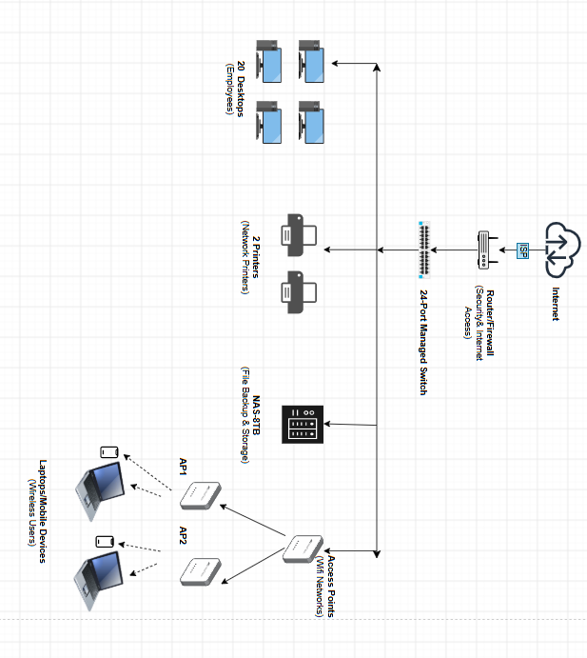
6.2 Network Components
ISP
The Internet Service Provider supplies the company's internet connection.
Router/Firewall
The router/firewall connects the internal network to the internet and provides security controls.
Managed Switch
The switch connects the company's wired devices.
Wireless Access Points
Two access points provide wireless connectivity throughout the office.
Desktop Computers
Twenty desktop computers provide workstations for employees.
Laptops
Five laptops provide mobility, particularly for management and employees requiring flexible working.
Network Printers
Two printers are connected to the network and shared by authorized employees.
NAS
The NAS provides centralized file storage and backup capabilities.

